**Lab 4P: Decision Structures and Boolean Logic_ 4P_DSBLX**

**GADDIS Text Pages 152 - 155**

**Using the IDLE editor (FILE/New Window)……**

**Name: __________Jeff Couch________________________________**

**EXTRA CREDIT = 150 Pts (7 Projects)**

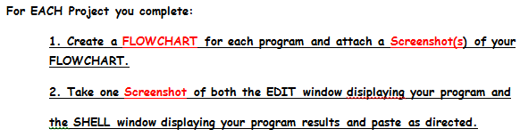

**Project 2. Areas of Rectangles (15 Pts)**

**Input: Length1 = 30, Width1 = 45, Lenght2 = 25, Width2 = 50**

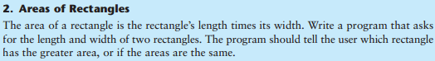

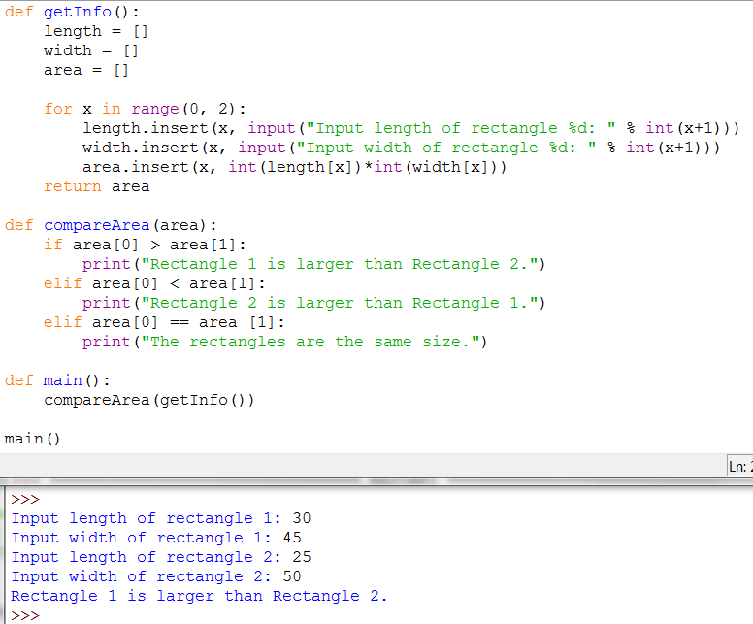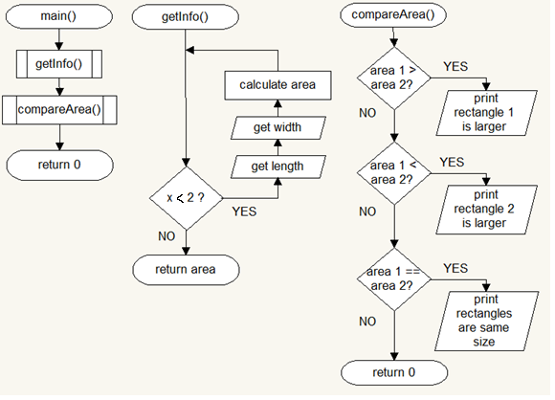

**Project 3: Mass and Weight (20 Pts)**

**Input: mass(kilograms) = 225**

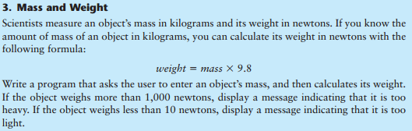

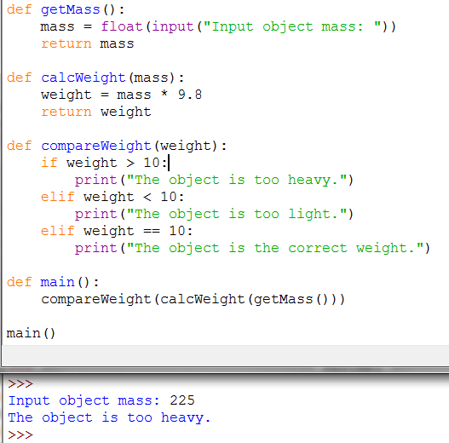

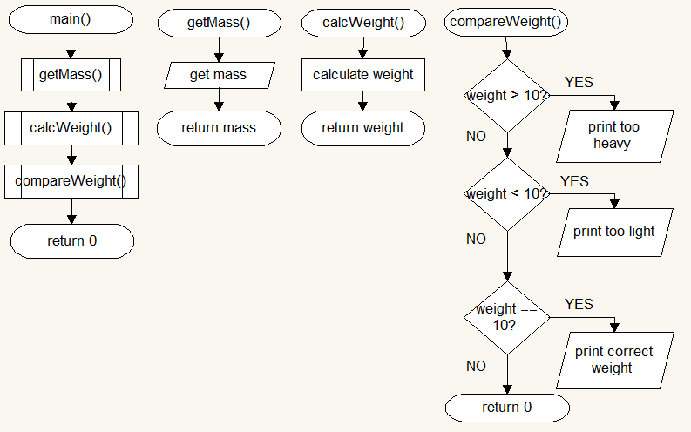

**Project 5: Color Mixer (25 Pts)**

**Input: color1 = blue, color2 = red… color1 = green**

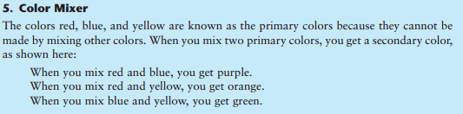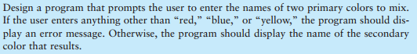

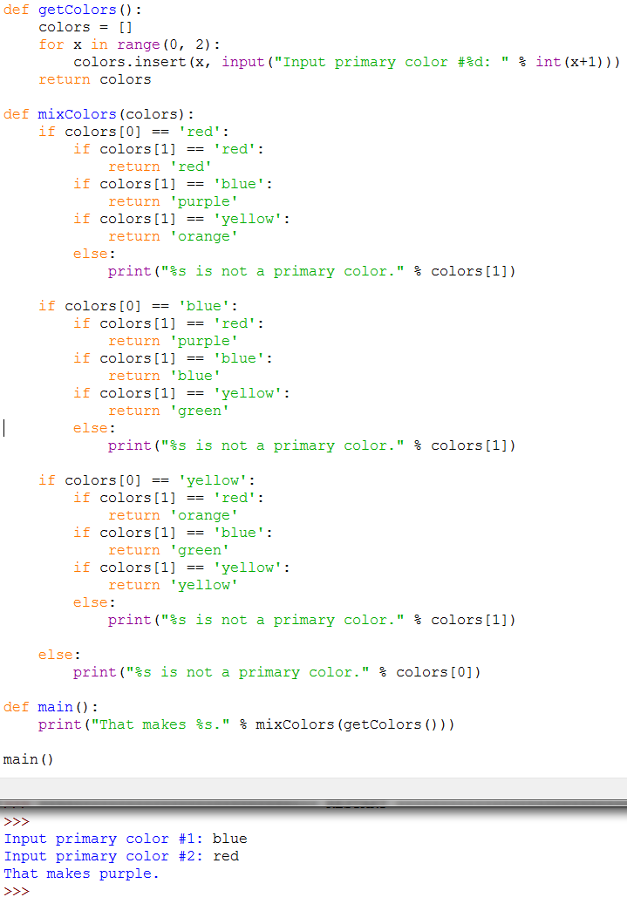

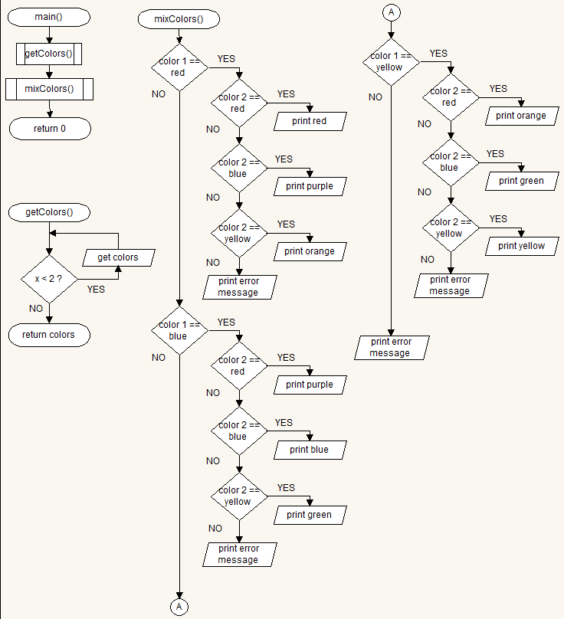

**Project 6: Change for a Dollar Game (40 Pts)**

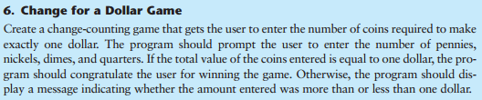

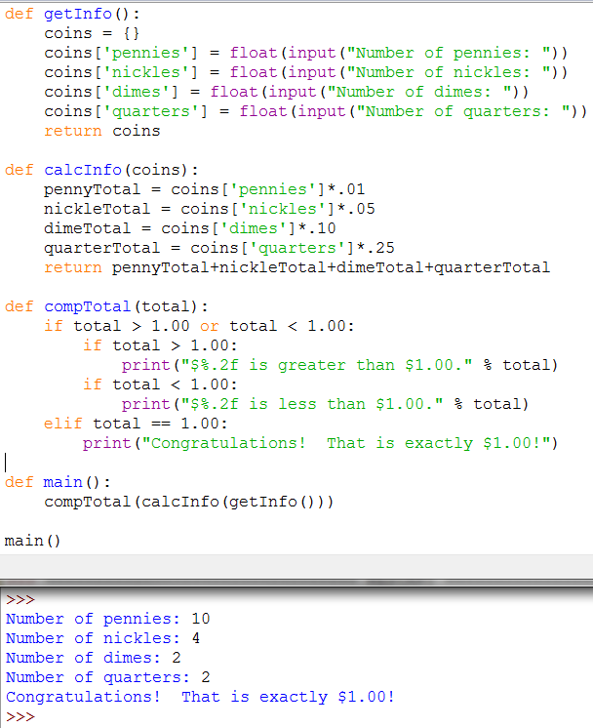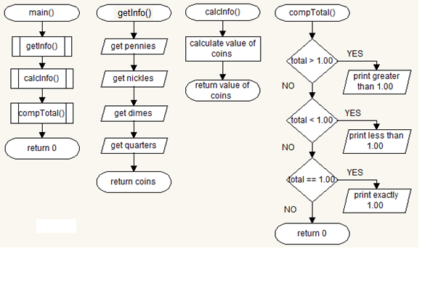

**Project 8: Software Sales (15 Pts)**

**Input: Packages = 25**

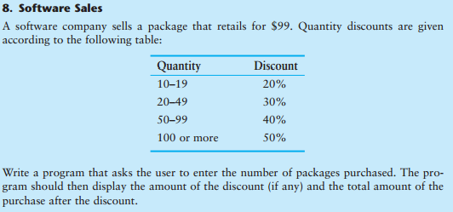

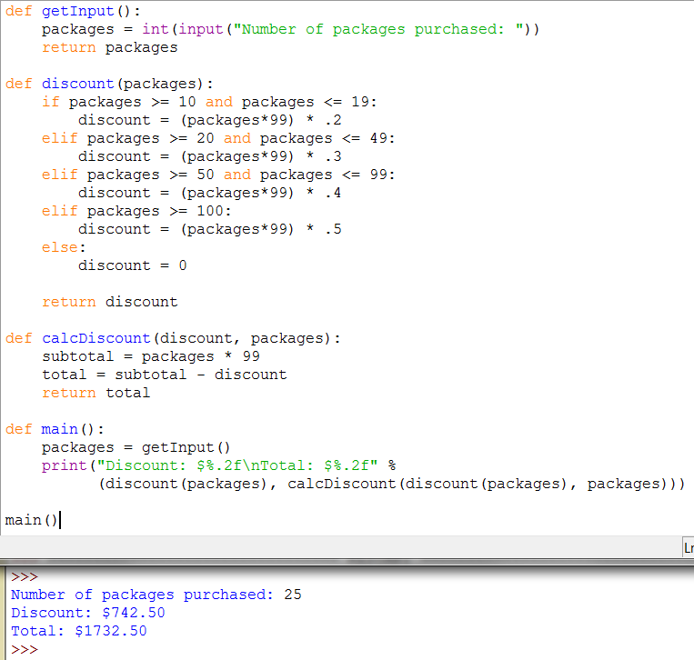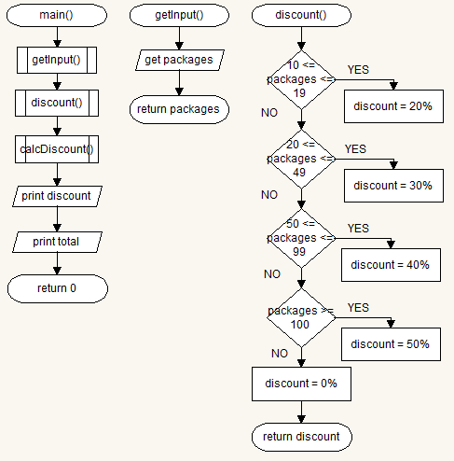

**Project 9: Shipping Charges (15 Pts)**

**Input: Weight(lbs) = 13**

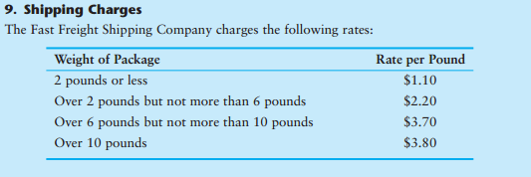

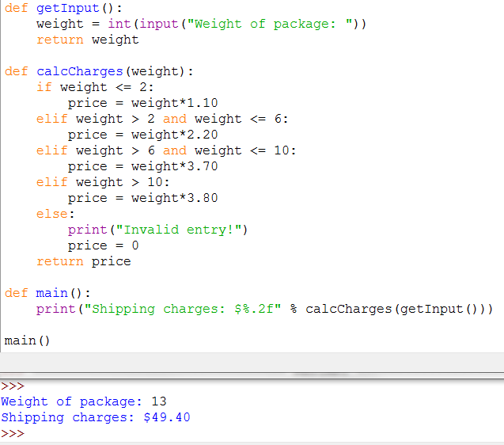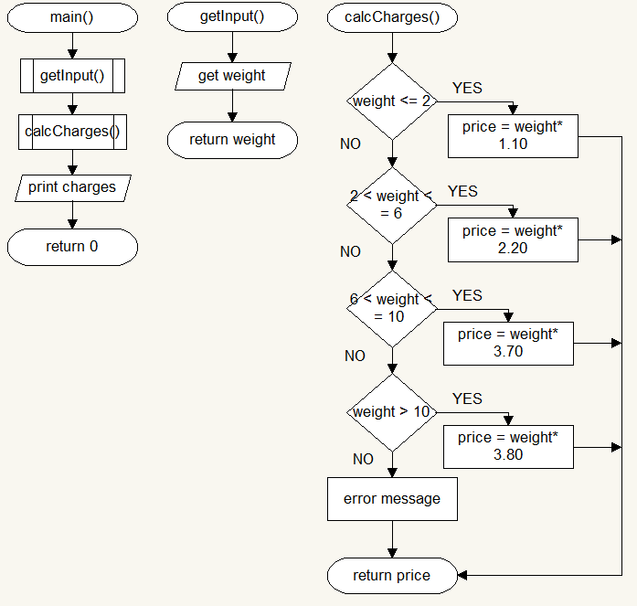

**Project 10: Body Mass Index Program Enhancement (20 Pts)**

**Input: Weight(lbs) = 175, Height(In) = 69**

